Multiplication and Division Interventions:

Skill- Multiplication within 100

Intervention- Number 43: Rings and Circles (page 29)

Source or adapted from - Intervention Tool-Kit for Math 3-5 by Lauren Reynolds

Materials:
- Chicken rings
- Wikki Stix

Instructions for administration:

Supply each participating student with about two dozen Chicken Rings and six Wikki Stix. Pose a multiplication or division word problem. Let’s say you present this problem: “Camilla had 16 cookies that she wanted to share with 2 friends. How many cookies would each friend get if Camilla shared equally? Would there be any left over?” Each student uses the Wikkis to create one circle representing Camilla and one representing each friend. She then distributes the Chicken Rings evenly inside the circles, laying down one at a time until no more can be given out evenly. In this case the number of rings inside one circle represents how many cookies each person would get, and the number of rings left over is the remainder.

For multiplication, change the problem to something like this: “Camilla and her two friends had 6 cookies each. How many cookies did the girls have in total?” The Wikki circles would still represent the friends, but this time each circle would get six Chicken Rings. The total number of rings distributed in all the circles would be the answer: 3 x 6= 18.

Suggested Progress Monitoring Tool:
Progress Monitoring Tools for Multiplication and Division can be found at the end of this document.

Skill- Multiplication within 100

Intervention- Amazing Arrays (page 119-121)

Source or adapted from – RTI & Math: The Classroom Connection by Darlene Doster

Materials:
- Fifty counters of a least five different colors for each student
- One 11” x 14” sheet of unlined paper and a pencil for each student
- Overhead projector and transparent colored counters or whiteboard, chalkboard, or large flip chart with stick-on counters
- Number Strip, up to the number 20 for each child, Appendix B, p. 262-attached at bottom
- Small whiteboard and marker for each student (optional)
- Teacher Key form, Appendix B, p. 250, attached at end of this intervention

Instructions for administration:
Part 1A- Multiplication with Manipulatives
- Explain to students that they will be using the operation of multiplication. Multiplication of numbers is similar to addition because each calls for adding numbers by groups. Multiplication is a much quicker way of adding large numbers.
- Using the overhead, tell the students you will be making arrays (groups of counters that create patterns). Arrays are one way to represent multiplication by grouping numbers together.
- Show them how to arrange six counters in two groups of three. Point out Group 1 and 2 and then the three items in each group. Tell them to look carefully at the pattern or array created by the grouping. Ask, “How many counters are in the array?”
- Rearrange the array to show three groups of two. This time, point out the three groups the two items in each group. Have students explain how the pattern differs from the first array. Ask students to determine the total number of counters in this array. Discuss why the number remains the same even though the arrangement changed.
- Demonstrate a few more examples, then have the students make their own arrays as they follow your directions (e.g., make an array with three groups of four, then four groups of three). If students have not discovered that they can skip count each group to arrive at the answer, show them this process.
- Have students complete several more arrays as you check for understanding. Encourage students to picture the equal groups and how many items in each group as a way to develop mental math images.
- Once students can arrange and count arrays, they are ready to use them with numbers strips to deepen their understanding of number relationships using the operation of multiplication.

Suggested Progress Monitoring Tool:
Progress Monitoring Tools for Multiplication and Division can be found at the end of this document.

Skill- Multiplication with 100

Intervention- Strategies for Multiplication Facts pp. 88 – 91

Source or adapted from - Teaching Student-Centered Mathematics 3-5 (Van de Walle)

Materials:
None

Instructions for administration:

It is imperative that students completely understand the commutative property. For example, 2 x 8 is related to the addition fact double 8. But the same relationship also applies to 8 x 2 that many students think about as 2 + 2 + 2 + 2 + 2 + 2 + 2 + 2. Most of the fact strategies are more obvious with the factors in one order than in the other, but turnaround facts should always be learned together. Of the five groups or strategies discussed next, the first four strategies are generally easier and cover 75 of the 100 multiplication facts.

Doubles - Facts that have 2 as a factor are equivalent to the addition doubles (e.g. 7 + 7) and should already be known by students who know their addition facts. The major problem is to realize that not only is 2 x 7 double 7, but so is 7 x 2. Try words problems where 2 is the number of sets. Later use problems where 2 is the size of the sets. Make and use flash cards with the related addition fact or word double as a cue.

Fives Facts – This group consists of all facts with 5 as the first or second factor, as shown here. Practice counting by fives with rows of 5 dots. Point out that six rows is a model for 6 x 5, eight rows is 8 x 5, and so on.

Zeros and Ones – Thirty-six facts have at least one factor that is either 0 or 1. These facts, though apparently easy, sometimes confuse students with “rules” they may have learned for addition. The fact 6 + 0 stays the same, but 6 x 0 is always zero. The 1 + 4 fact is a one-more idea, but 1 x 4 stays the same. The concepts behind these facts can be developed best through story problems. Above all else, avoid rules that sound arbitrary and without reason such as “Any number multiplied by zero is zero. “

Nifty Nines – Facts with a factor of 9 include the largest products but can be among the easiest to learn. The table of nines facts includes some nice patterns that are fun to discover. Two of these patterns are useful for mastering the nines: 1) The tens digit of the product is always one less than the “other” factor (the one other than nine), and 2) the sum of the two digits in the product is always 9. These 2 ideas can be used together to get any nine fact quickly. Consider word problems with a factor of 9 to see if the strategy is in use. An alternative strategy for the nines is almost as easy to use. Notice that 7 x 9 is the same as 7 x 10 less one set of 7, or 70 – 7. This can easily be modeled by display8ing rows of 10 cubes, with the last one a different color. For students who can easily subtract 4 from 40, 5 from 50, and so on, this strategy may be preferable.

Helping Facts –
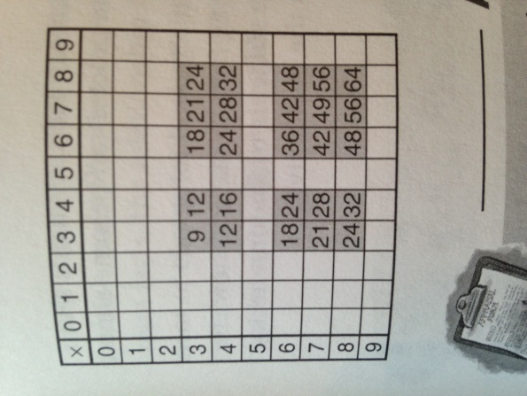

– This chart shows the remaining multiplication facts. It is worth pointing out to students that there are actually only 15 facts remaining to master because 20 of them consist of 10 pairs of turnarounds. These 25 facts can be learned by relating each to an already known fact or helping fact. For example, 3 x 8 is connected to 2 x 8 (doubles 8 and 8 more). The 6 x 7 fact can be related to either 5 x 7 (5 sevens and 7 more) or to 3 x 7 (double 3 x 7). The helping fact must be known, and the ability to do the mental addition must also be there. For example, to go from 5 x 7 is 35 and then add 7 for 6 x 7, a student must be able to efficiently add 35 and 7.

Suggested Progress Monitoring Tool:
Progress Monitoring Tools for Multiplication and Division can be found at the end of this document.

Skill- Multiplication within 100

Intervention- Multiplication by a Single-Digit Multiplier

Source or adapted from - Teaching Student-Centered Mathematics 3-5 (Van de Walle)

Materials:
None

Instructions for administration:
It is helpful to place multiplication tasks in contextual story problems. Let students model the problems in ways that make sense to them.

The following three categories can be identified from the research to date.
1) Complete-Number Strategies / Students who are not yet comfortable breaking numbers into parts using tens and ones will approach the numbers in the sets as single groups. These students will benefit from listening to students who use base-ten models. They may also need more work with base-ten grouping activities where they take numbers apart in different ways.

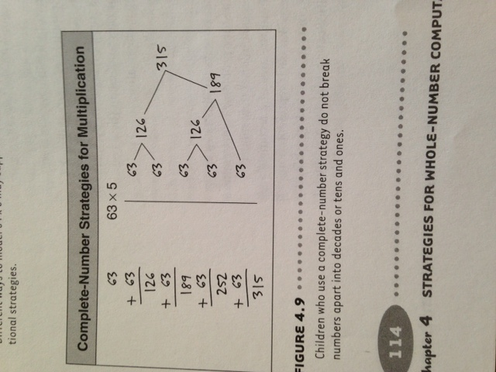

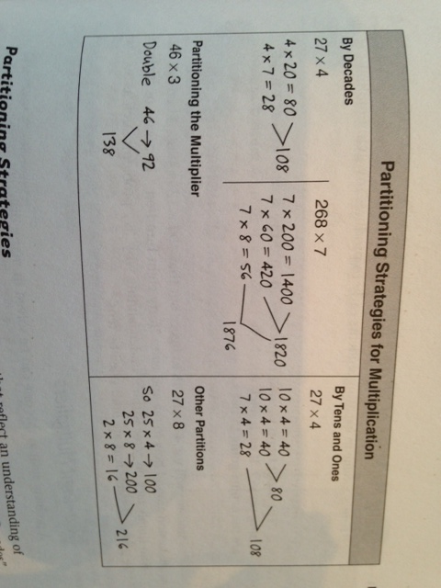
2) Partitioning Strategies / Students break numbers up in a variety of ways that reflect an understanding of base-ten concepts. The “By Decades” approach is the same as the standard algorithm except that students always begin with the large values. It extends easily to three digits and is very powerful as a mental math strategy. Another valuable strategy for mental methods is found in the “Other Partitions” example. It is easy to compute mentally with multiples of 25 and 50 and then add or subtract a small adjustment. All partition strategies rely on the distributive property.

3) Compensation Strategies / Students look for ways to manipulate numbers so that the calculations are easy. For example, the problem 27 x 4 is changed to an easier one, and then an adjustment or compensation is made. In the second example, one factor is cut in half and the other doubled. This is often used when a 5 or a 50 is involved. Because these strategies are so dependent on the numbers involved, they can’t be used for all computations. However, they are powerful strategies, especially for mental math and estimation.
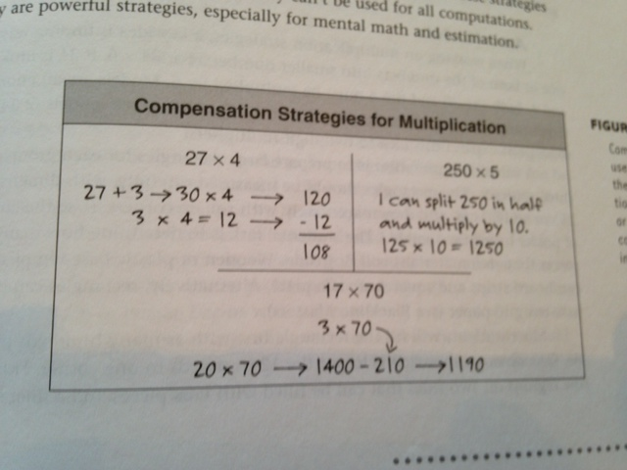

Suggested Progress Monitoring Tool:
Progress Monitoring Tools for Multiplication and Division can be found at the end of this document.
Skill- Division within 100

Intervention- Learning About Division (page 92-93)

Source or adapted from - Teaching Student-Centered Mathematics K-3 (Van de Walle)

Materials:
- Students will each need about 35 counters
- If possible, provide students with small paper cups or portion cups that will hold at least 6 counters. Alternatively, students can stack counters in piles.

Instructions for administration:
Before:
Begin with a Simpler Version of the Task
- Draw 13 dots on the board. Ask: How many sets of 3 dots can we make if we have 13 to work with? How many will be left over? Most students should be able to answer this question mentally. After receiving several answers, have a student come to the board and demonstrate how to verify the answer of 4 sets of 3 and 1 left.
- Ask: What equation could we write for what we have on the board? Accept students’ ideas. Correct ideas include:
  - 3 + 3 + 3 + 3 +1 = 13
  - 4 x 3 + 1= 13 (3 x 4 + 1 technically represents 3 sets of 4 and 1 more.)
  - 13/3 = 4 R 1
Note: If this is the introduction to division symbolism, you may want to use 12 instead of 13 so that there are no remainders. However, it is also okay to begin this way.
- Say: Think of a situation in which someone might have 13 things and wants to find out how many sets of 3. Make up a story problem about your situation. Have several students share their story problem.
The Task
- Begin with a set of 31 counters. Use the counters to see how many sets of 4 you can make. Repeat with a set of 27 counters and find out how many sets of 6 you can make.
Establish Expectations
- Write the directions on the board:
  - 31 counters-how many sets of 4?
  - 27 counters- how many sets of 6?
- Explain (and record on the board) that for each of these tasks students are to:
  - Write three equations: one addition, one multiplication, and one division
  - Write a story problem to go with their division equation.

During:
- Ask students to explain why their equations go with what they did with the counters. Do not correct incorrect equation or story problems. You only want to be sure students are attempting to connect the activity with the symbolism and the stories.
- Challenge early finishers to see if they can do the same thing for a set of 125 things in piles of 20. However, they will have to figure it out without using counters.

After:
- For 31 counters in sets of 4, ask how many sets and how many are left over. Most students should agree that there are 7 sets and 3 left over. Draw a picture that looks similar to those you have seen on students’ papers.
- Have a number of students share their equations. After several equations are on the board, ask those who have different equations to share theirs as well.
- Have students explain how their equations match what was done with the counters. If students disagree, have them politely explain their reasoning. Students should be comfortable with their ideas about the multiplication and addition equations. For an introductory lesson on division, you should correct any misunderstandings about the division equation and what it means.
- Have several students share their story problems. Students should explain how the story situation matches the action of finding how many sets of 4 in 31. For example: “There were 31 apples in the basket. If each apple tart requires 4 apples, how many tarts can be made?”
- If time permits, repeat with the 27/6 situation.

Suggested Progress Monitoring Tool:
Progress Monitoring Tools for Multiplication and Division can be found at the end of this document.

Skill- Division Word Problems

Intervention- Sharing and Measurement Problems

Source or adapted from - Teaching Student-Centered Mathematics K-3 (Van de Walle)

Instructions for administration:

Recall that there are two concepts of division. First there is partition or fair-sharing idea, illustrated by this story problem:
The bag has 783 jelly beans, and Aidan and her four friends want to share them equally. How many jelly beans will Aidan and each of her friends get?

Then there is the measurement or repeated subtraction concept:
Jumbo the elephant loves peanuts. His trainer has 625 peanuts. If he gives
Jumbo 20 peanuts each day, how many days will the peanuts last?

Students should be challenged to solve both types of problems. However, the fair-share problems are often easier to solve with base-ten pieces. Furthermore, the traditional algorithm is built on this idea. Eventually, students will develop strategies that they will apply to both types of problem, even when the process does not match the action of the story.

Figure 4.16 shows some strategies that fourth-grade students have used to solve division problems.

Figure 4.16

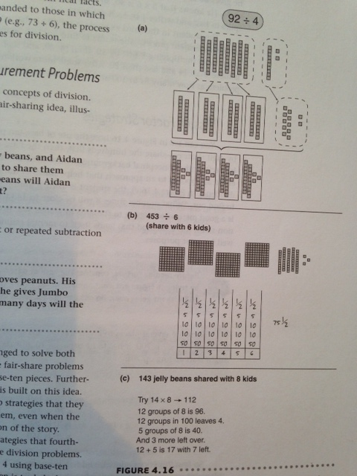
The first example illustrates 92 divided 4 using base-ten pieces and a sharing process. A ten is traded when no more tens can be passed out. Then the 12 ones are distributed, resulting in 23 in each set. This direct modeling approach with base-ten pieces is quite easy even for third grade students to understand and use.

In the second example, the student sets out the base-ten pieces and draws a “bar graph” with six columns. After noting that there are not enough hundreds for each kid, he mentally splits the 3 hundreds if half, putting 50 in each column. That leaves him with 1 hundred, 5 tens, and 3 ones. After trading the hundred for tens (now 15 tens) he gives 20 to each, recording 2 tens in each bar. Now he is left with 3 tens and 3 ones, or 33. He knows that 5 x 6 is 30, so he gives each kid 5, leaving him with 3. These he splits in half and writes ½ in each column.

The student in the third example is solving a sharing problem but tries to do it as a measurement process. She wants to find out how many 8s are in 143. Initially she guesses. By multiplying 8 first by 10, then by 20, and then by 14, she knows the answer is more than 14 and less than 20. After some more work (not shown), she rethinks the problem as how many 8s in 100 and how many in 40.

Suggested Progress Monitoring Tool:
Progress Monitoring Tools for Multiplication and Division can be found at the end of this document.

Skill- Multiplication and Division Word Problems

Intervention- Using Model-based Problems

Source or adapted from - Teaching Student-Centered Mathematics 3-5 (Van de Walle)

Materials:
None

Instructions for administration:

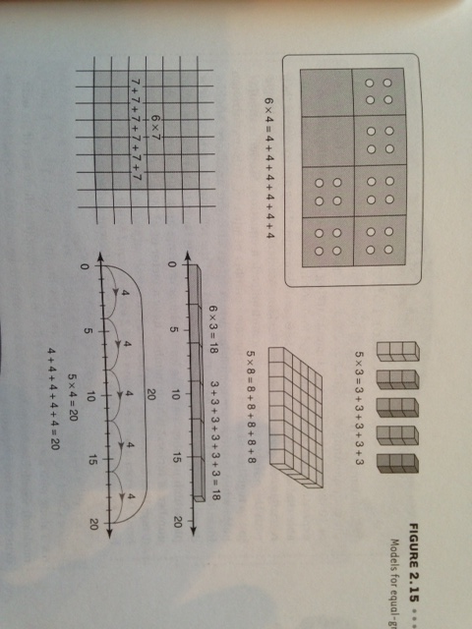

A model not generally used for addition but extremely important and widely used for multiplication and division is the array. An array is any arrangement of things in rows and columns, such as a rectangle of square tiles or blocks.

To make clear the connection to addition, early multiplication activities should also include writing an addition sentence for the same model. A variety of models are multiplication “names” are written. This is another way to avoid the tedious counting of large sets. A similar approach is to write one sentence that expresses both concepts at once, for example, 9 + 9 + 9 + 9 = 4 x 9.

Suggested Progress Monitoring Tool:
Progress Monitoring Tools for Multiplication and Division can be found at the end of this document.

Skill- Multiplication and Division Word Problems

Intervention- Two-Step Problems

Source or adapted from - Teaching Student-Centered Mathematics 3-5 (Van de Walle)

Materials:
None

Instructions for administration:

Students often have difficulty with multistep problems. If your students are going to work with multistep problems, be sure they can analyze one-step problems in the way that we have discussed. The following ideas are designed to help children see how two-step problems can be chained together.

1. Give students a one-step problem and have them solve it. Before discussing the answer, have each student or group make up a second problem that uses the answer to the first problem. The rest of the class can then be asked to use the answer to the first problem to solve the second problem.

2. Make a “hidden question.” Repeat the first exercise by beginning with a one-step problem. You might give different problems to different groups. This time, have students write out both problems as before. Then, write a single related problem that leaves out the question from the first problem. That question from the first problem is the “hidden question.”

Have other students identify the hidden question. Since all students are working on a similar task but with different problems (be sure to mix the operations), they will be more likely to understand what is meant by a hidden question.

3. Pose standard two-step problems, and have the students identify and answer the hidden question.

Begin by considering the questions that were suggested earlier: “What’s happening in this problem?” “What will the answer tell us?” These questions will get you started. If students are stuck, you can ask, “Is there a hidden question in this problem?”

Skill- Multiplication Quantities Great than 100

Intervention- Two-Digit Multipliers (pp. 116 – 117)

Source or adapted from - Teaching Student-Centered Mathematics 3-5 (Van de Walle)

Instructions for administration:
Area Models – When working on multiplication strategies, a key idea is finding ways to break one or both of the numbers into smaller numbers. For 34 x 6, if 34 is broken into 30 and 4, both the 30 and the 4 must be multiplied by 6. Models are an enormous help in developing this idea. An area model can expand this idea to two-digit multipliers. A valuable exploration is to prepare large rectangles for each group of two or three students. The rectangles should be measured carefully, with dimensions between 25 cm and 60 cm, and then drawn accurately with square corners. (Use the corner of a piece of poster board for a guide.) The students’ task is to determine how many small ones pieces (base-ten materials) will fit inside. Wooden or plastic base-ten pieces are best, but cardboard strips and squares are adequate. Alternatively, rectangles can be drawn on base-ten grid paper. Most students will fill the rectangle first with as many hundreds pieces as possible. One obvious approach is to put the 12 hundreds in one corner. This will leave narrow regions on two sides that can be filled with tens pieces and a final small rectangle that will hold ones. Especially if students have had earlier experiences with finding products in arrays, figuring out the size of each subrectangle is not terribly difficult. The area model leads to a fairly reasonable approach to multiplying numbers, even if you never have students “carry”, which is a source of many errors.
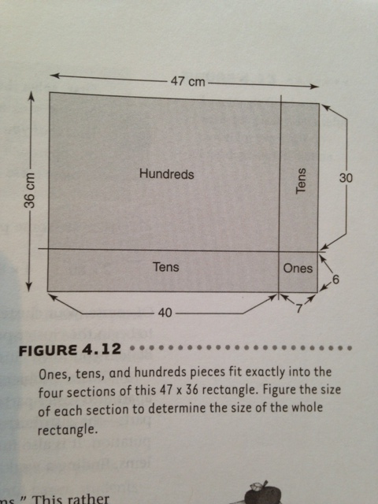

Suggested Progress Monitoring Tool:
Progress Monitoring Tools for Multiplication and Division can be found at the end of this document.
Progress Monitoring Tools

Progress Monitoring Tools for Fact Fluency:
Multiplication and Division probes can be custom made to meet the student’s individual needs and goals at http://www.interventioncentral.org/teacher-resources/math-work-sheet-generator. Choose the appropriate operation (We only recommend single-skill probes for RTI purposes), then the amount of problems and the range of numbers. 10 facts are enough and easily measured for reporting purposes. Timing students is highly discouraged.

Important Notes about Multiplication and Division Fluency:

Fluently multiply and divide within 100, using strategies such as the relationship between multiplication and division (e.g., knowing that 8 × 5 = 40, one knows 40 ÷ 5 = 8) or properties of operations. By the end of Grade 3, know from memory all products of two one-digit numbers.

Students who demonstrate full accomplishment can multiply any two numbers with a product within 100 with ease by picking and using strategies that will get to the answer fairly quickly and/or can instantly recall from memory the product of any two one-digit numbers.

Students who demonstrate partial mastery may have efficient strategies for some multiplication and division facts, but may rely on other strategies such as making arrays, equal groups and/or repeated addition/subtraction to solve for facts that they have not mastered.

Progress Monitoring Tool for Conceptual Understanding of Mult./Div. and/or Problem-solving:

Directions:

- Display or give each student a copy of the word problem.
- Students should use a problem solving strategy such as drawings or equations to represent the problem. Students should display their work on the page.
- Consider having students work in pairs/groups and then share the variety of ways they solved the problem.

Considerations:

Watch to see if students are able to understand the problem.
- Did each student use an appropriate strategy to solve the problem?
- Do the students arrive at the correct solution?

Collecting Data:
Student performance can be scored with a provided task rubric or a rubric created by the teacher.
Data can be recorded on a score sheet.

Not yet: Student shows evidence of misunderstanding, incorrect concept or procedure |  | Got It: Student essentially understands the target concept.
0 Unsatisfactory:  Little Accomplishment  The task is attempted and some mathematical effort is made. There may be fragments of accomplishment but little or no success. Further teaching is required. | 1 Marginal:  Partial Accomplishment  Part of the task is accomplished, but there is lack of evidence of understanding or evidence of not understanding. Further teaching is required. | 2 Proficient:  Substantial Accomplishment  Student could work to full accomplishment with minimal feedback from teacher. Errors are minor. Teacher is confident that understanding is adequate to accomplish the objective with minimal assistance. | 3 Excellent:  Full Accomplishment  Strategy and execution meet the content, process, and qualitative demands of the task or concept. Student can communicate ideas. May have minor errors that do not impact the mathematics.

A classroom has 24 students who sit at 6 tables. The students will be doing a project where they’ll each need one piece of construction paper. The teacher wants to pass the paper out quickly. How many sheets should be laid at each table so that each student has a piece of paper?
FFirst Second Third Fourth Fifth
Tower Tower Tower Tower Tower
Name __________________________
Work Space:

Answer: ______________

Teacher notes:
Use multiplication and division within 100 to solve word problems in situations involving equal groups, arrays, and measurement quantities, e.g., by using drawings and equations with a symbol for the unknown number to represent the problem.

Students who demonstrate mastery can determine when to multiply and divide in word problems. They can represent multiplication and division word problems using drawings (arrays), number lines and equations with unknowns in all positions.

Students who demonstrate partial mastery may apply an appropriate strategy, but may miscount using pictures or a number line and end up with an incorrect answer.

*See “Additional Problem Solving Structures” under the Interventions page for more examples.
Progress Monitoring Tools for Multi-Digit Multiplication:

Name ______________________________ Date ___________________

3. Solve
2. Circle the best strategy. | Algorithm  Rectangular array  Area model | Algorithm  Rectangular array  Area model | Algorithm  Rectangular array  Area model
1. Read the equation. | 27 x 38 = | 12 x 3 = | 3,407 x 6 =
Name ____________________ Date _______________

3. Solve
2. Circle the best equation for this strategy. | 12 x 58 =  4 x 3 =  1,265 x 3 = | 12 x 58 =  4 x 3 =  1,265 x 3 = | 12 x 58 =  4 x 3 =  1,265 x 3 =
1. Read the strategy. | Rectangular Array | Algorithm | Area Model

Progress Monitoring tools for Division:

Name ___________________________ Date ___________

3. Solve
2. Circle the best strategy. | Algorithm  Rectangular Array  Area Model | Equation  Rectangular Array  Area Model | Equation  Rectangular Array  Area Model
1. Read the equation. | 606 ÷ 5 = | 42 ÷ 7 = | 3,738 ÷ 6 =
Name _______________________________ Date _________________

3. Solve
2. Circle the best equation for this strategy. | 15 ÷ 3 =  98 ÷ 32 =  1,092 ÷ 7 = | 15 ÷ 3 =  98 ÷ 32 =  1,092 ÷ 7 = | 15 ÷ 3 =  98 ÷ 32 =  1,092 ÷ 7 =
1. Read the strategy. | Rectangular Array | Algorithm | Area Model

